THE BLYTHEWOOD HISTORICAL SOCIETY AND MUSEUM
CELEBRATES BLACK HISTORY MONTH
FEBRUARY 26 & 27, 2022
HONORING
THE LEGACY AND HERITAGE OF BETHEL-HANBERRY HIGH SCHOOL
1946 – 1970 AND BEYOND
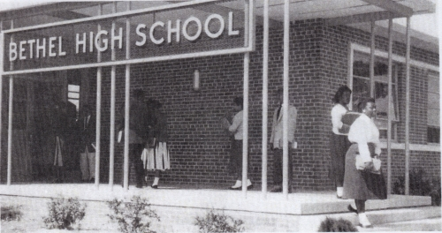
The Blythewood Historical Society and Museum is pleased to announce its 2022 BLACK HISTORY PROGRAM.

This year’s program will honor the legacy and history of Bethel-Hanberry High School. The event will be a 2-day event beginning on February 26 at the historic gymnasium and culminate with an interesting community program on February 27, 2022, at Doko Meadows in Blythewood. We are inviting former students, faculty and any other employees who were a part of Bethel-Hanberry during the years of 1946 to 1970 and beyond to join us on the above dates as we commemorate and celebrate this iconic only educational institution for Black students in Blythewood during this time.
Registration is required to attend, so please register in advance and by contacting our office, 803-333-8133 to register via phone or go to our website at https://blythewoodhistoricalsociety.org
and complete the Registration Form online. You may also register in person by stopping by the office located at 100 McNulty Street and register in person.

PLEASE NOTE THAT THESE EVENTS WILL FOLLOW STRICT CDC AND DHEC GUIDELINES FOR REQUIRED VACCINATIONS, BOOSTERS AND MASKS!

