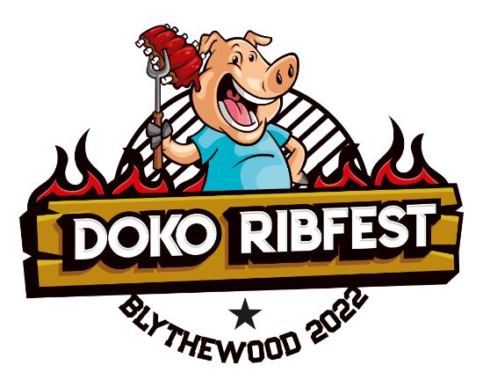

Presented by The Greater Blythewood Chamber of Commerce and
The Town of Blythewood at Doko Meadows Park, Blythewood, SC
March 11, 2022 – 6 pm to 10 pm and March 12, 2022 – 7 am to 10 pm
Ribs Food Beer Music Fun
On both days there will be food trucks, specialty food/sweets vendors, and activity vendors. Spaces also are available for qualified local non-profit organizations WITH NO VENDOR FEE.
There will be 3 beer stations provided. 1 in the farmers market field and 2 in the amphitheater. Food and stand-up tables will be provided for your food and beverage consumption. We will also have a fenced VIP tented area (with tables and seating) in the amphitheater area for enjoyment of the entertainment as well as additional tables and seating for food and beverage consumption.
Rib Cook-Off competitors will have a Chili Cook Off on Friday evening with $2.00 sampling tickets.
Friday evening entertainment will be a movie presentation of at 6:30 pm of followed by music provide by Tokyo Joe – 8:00 pm to 10:00 pm
Rib Cook-Off competition is to commence with standard portions of ribs passed out at 6:00 am to contestants on Saturday March 12 in the farmers market field. Contestants will have until judging time(s) to prepare their offerings. Judging by Southern Barbecue Network judges is to commence at 11:00 am, 12:00 pm, and 1:00 pm in the Judges Tents with winners to be announced at 4:00 pm.
Up to 80 competition cook teams preparing 10,000 lbs. of ribs in three competitive divisions, each with entry fees with trophies presented to the winners. Total prize money distributed as follows:
Professional - $4,000.00 Amateur -$3,000.00 Veterans - $1,200.00
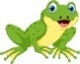
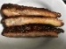
Tickets for personal tastings of the competing team’s offerings are available for $2.00 per tasting. You may also purchase a full rack of ribs for $30.00 and/or rib plates (3 ribs, barbecue beans and coleslaw) for $12.00. These items will be available on Saturday from 12:00 pm until SOLD OUT.
Saturday morning continues with our Ribbit Run (5k) from 7:00 am to 9:00 am.
Bloody Mary’s at 9:00 am and musical acts on March 12 follow from 9:00 am until 10:00 pm:
Commontime Bluegrass Band - 9:00 am to 11:00 am
Too Much Sylvia - 11:30 am to 1:30 pm Mason Horne - 2:00 pm to 4:00 pm
Wrong Side of the Tracks – 4:30 pm to 6:30 pm Blues Deluxe – 7:00 pm to 10 :00 pm

SPONSORSHIP OPPORTUNITIES
SPONSORSHIP OPPORTUNITIES
Presenting Sponsor – Town of Blythewood
Title Sponsor - Broom Heating, Air and Electrical $ 4,000 - SOLD
Premier placement of company logo banner at each main tent at the event. Company logo and/or name included on: Media release, ads, posters, event website/facebook page, e-mail marketing. 12 VIP tent admissions and 60 tickets for Tastings or 4 Full Rack of Ribs. Opportunity for customer engagement/product placement. Live stage mentions at the event.
Wristband Sponsor – Founders Federal Credit Union $ 2,000 - SOLD
Premier placement of company logo banner at the event. Company logo and/or name included on: Media release, ads, posters, event website/facebook page, e-mail marketing. 8 VIP tent admissions and 45 tickets for Tastings or 3 Full Rack of Ribs. Opportunity for customer engagement/product placement. Live stage mentions at the event. Wristbands for I.D. for eligibility consumption of adult beverages.
Tent Sponsors - Beer Tents – $ 2,000 - ALL 3 SOLD
Judges Tasting Tent $ 2,000 - SOLD
Premier placement of company logo banner at your tent at the event. Company logo and/or name included on: Media release, ads, posters, event website/facebook page, e-mail marketing. 6 VIP tent admissions and 45 tickets for Tastings or 3 Full Rack of Ribs. Opportunity for customer engagement/product placement. Live stage mentions at the event.
Corporate Sponsor - 7 SOLD $ 1,000 - (2 available)
Placement of company logo banner at the event tent of your choice. Company logo and/or name included on: Media release, ads, posters, event website/facebook page, e-mail marketing. 4 VIP tent admissions and 30 tickets for Tastings or 2 Full Rack of Ribs. Opportunity for customer engagement/product placement. Live stage mentions at the event.
Rib Contestants Division Sponsor – 3 SOLD $500 - (7 available)
Placement of company logo banner at Tasting/Judging tent at the event. Company logo and/or name included on: Media release, ads, posters, event website/facebook page, e-mail marketing. 2 VIP tent admissions and 15 tickets for Tastings or 1 Full Rack of Ribs. Opportunity for customer engagement/product placement. Live stage mentions at the event.

SPONSORSHIP OPPORTUNITIES
Rib Contestant Team Sponsor - $200 – (50 available)
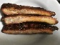
Yard sign for your business noting “DOKO Rib Fest Cook Off in the Park Team Sponsor”. Acknowledgement of your sponsorship on Chamber website/facebook page and e-mail marketing. 15 tickets for Tastings or 1 Full Rack of Ribs.
Ribbit Run Event Sponsor – Lexington Medical Center - $1,000 - SOLD
Placement of company logo banner at the stage Finish Line Banner as Ribbit Run Event Sponsor. Company logo and/or name included on: Media release, ads, posters, event website/facebook page, e-mail marketing and on Ribbit Run T-shirts. Opportunity for customer engagement and Event winner stage presentations at the event. Entry of 8 runners/walkers in the Ribbit Run Event. 4 VIP tent admissions and 30 tickets for Rib Fest Cook Off Tastings or 2 Full Rack of Ribs.
Ribbit Run (5k) Division Sponsor - 3 SOLD $500 - (3 available)
Placement of company logo banner on site as Ribbit Run Division Sponsor (2 available for each of Senior, Adult, or Youth Divisions). Company logo and/or name included on: Media release, ads, posters, event website/facebook page, e-mail marketing and on Ribbit Run T-shirts. Opportunity for customer engagement and Division winner stage presentations at the event. Entry of 4 runners/walkers in the Ribbit Run Event. 4 VIP tent admissions and 15 tickets for Rib Fest Cook Off Tastings or 1 Full Rack of Ribs.
Ribbit Run (5k) Drink Station Sponsor - $250 - (6 available)
Placement of company logo banner as Ribbit Run Drink Station Sponsor. Company logo and/or name included on: Media release, ads, posters, event website/facebook page, e-mail marketing. Opportunity for customer engagement and Drink Station Sponsor stage mentions at the event.
Ribbit Run (5k) Course Sponsor - $100 – (25 available)
Yard sign for your business noting “DOKO Rib Fest Cook Off in the Park Ribbit Run Sponsor”. Acknowledgement of your sponsorship on Chamber website/facebook page and e-mail marketing.
ADHERENCE TO LOCAL CURRENT COVID GUIDELINES WILL BE IN PLACE.
Proceeds support the Greater Blythewood Chamber of Commerce economic development initiatives and scholarship programs with a portion to benefit designated non-profit groups.

