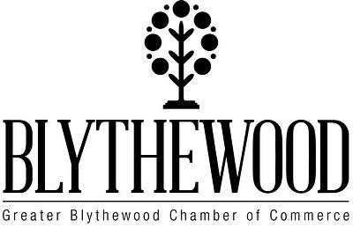
Doko Rib Fest Cook Off in the Park
March 13, 2021
Local Rules
- All teams are asked to cook 15 racks of St. Louis cut Ribs.
- Ribs will be passed out at 6:00 am on March 13, 2021.
- Ribs may be cooked on gas, electric, pellet, charcoal, or wood grill or smoker.
- You will need to pick out 3 racks for the contest for Southern Barbecue Network judges.
- You will need to put at least 8 bones in your turn in box for judges to sample.
- We will provide you with the turn in box.
- No garnish is allowed in the box.
- The rest of your ribs are for samples to the public with (bright green) tasting wristbands they have purchased beginning at 12:00 pm (noon). These tastings will be for voting for the People’s Choice Award to be announced along with each of the Division winners.
- Turn in times:
- 1:00 pm - Amateur Division
- 2:00 pm - Veterans Division
- 3:00 pm - Professional Division
- Winners will be announced at 5:00 pm at the Amphitheater stage.
Covid Guidelines are in place throughout the day with sanitation stations, socially distanced seating and entry/exit markings in place. Wear masks when not in your seating pods and practice effective sanitation procedures and social distancing.
Prize Money: Current IRS Form W-9 required to issue payment.
Amateur: Professional: Veteran
1st place - $1,300.00 1st place - $1,800.00 1st place - $450.00
2nd place - $ 650.00 2nd place - $ 900.00 2nd place - $300.00
3rd place - $ 350.00 3rd place - $ 400.00 3rd place - $150.00
4th place - $ 250.00 4th place - $ 300.00
5th place - $ 150.00 5th place - $ 200.00

